9.Execute and display the results for the following Nmap Timing and performance
commands in Kali Linux operating Systems:
(i) polite IDS evasion
(ii) normal IDS evasion

Aim: To execute Nmap timing and performance commands in Kali Linux using polite timing and normal timing.
(i) polite IDS evasion
Command:
nmap -sT -T2 -p 80,443 127.0.0.1
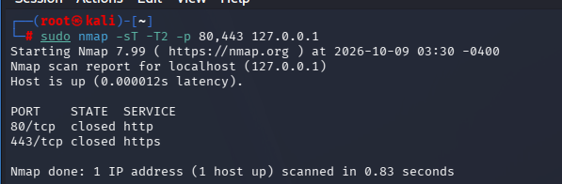

Explanation:
- -sT – Performs a TCP connect scan.
- -T2 – Uses polite timing with slower scanning.
- -p 80,443 – Scans ports 80 and 443.
- 127.0.0.1 – Refers to the local machine.

(ii) Normal Timing
Command:
nmap -sT -T3 -p 80,443 127.0.0.1
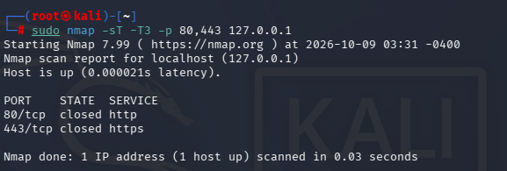
Explanation:
- -sT – Performs a TCP connect scan.
- -T3 – Uses normal timing, which is Nmap's default.
- -p 80,443 – Scans ports 80 and 443.
- 127.0.0.1 – Refers to the local machine.

Result:Nmap timing and performance commands were executed using polite timing (-T2) and normal timing (-T3) to scan ports 80 and 443 on the local machine.

